**ASSIGNMENT – HUAWEI DEVELOPER INTERNSHIP**

1. **SQL QUERY:**

//creating student table

create table student(name varchar(100), age integer, mobile_no varchar(100), reg_no integer, year_of_batch integer);

insert into student(name, age, mobile_no, reg_no, year_of_batch) values("Alfred", 20, 9384895632, 1905085, 2020);

insert into student(name, age, mobile_no, reg_no, year_of_batch) values("Friday", 21, 9387895632, 1905085, 2019);

insert into student(name, age, mobile_no, reg_no, year_of_batch) values("Freedom", 22, 2584895632, 1905085, 2018);

insert into student(name, age, mobile_no, reg_no, year_of_batch) values("Myskin", 21, 7894895632, 1905085, 2019);

insert into student(name, age, mobile_no, reg_no, year_of_batch) values("Jyothi", 20, 3698895632, 1905085, 2020);

insert into student(name, age, mobile_no, reg_no, year_of_batch) values("Aiswarya",19, 8744895632, 1905085, 2021);

insert into student(name, age, mobile_no, reg_no, year_of_batch) values("Kishor", 21, 9874895632, 1905085, 2019);

insert into student(name, age, mobile_no, reg_no, year_of_batch) values("Vikram", 20, 69874895632, 1905085, 2019);

insert into student(name, age, mobile_no, reg_no, year_of_batch) values("Ramkumar", 20, 7884895632, 1905085, 2020);

insert into student(name, age, mobile_no, reg_no, year_of_batch) values("Afrina", 22, 9874895632, 1905085, 2018);

select * from student;

//creating teachers table

create table teacher(name varchar(100), domain varchar(100), department varchar(100));

insert into teacher(name, domain, department) values("Anupama", "AI", "IT");

insert into teacher(name, domain, department) values("Nirmala", "Cyber Security", "IT");

insert into teacher(name, domain, department) values("John", "AR/VR", "IT");

insert into teacher(name, domain, department) values("peter", "ML", "IT");

insert into teacher(name, domain, department) values("Megana", "AI/DS", "IT");

insert into teacher(name, domain, department) values("Hariram", "Computer Architecture", "CSE");

insert into teacher(name, domain, department) values("preethi", "Mobile Communication", "CSE");

insert into teacher(name, domain, department) values("Niralya", "AI", "IT");

insert into teacher(name, domain, department) values("Akshaya", "Blockchain", "IT");

insert into teacher(name, domain, department) values("Abishek", "IOT", "CSE");

insert into teacher(name, domain, department) values("Lokesh", "RPA", "IT");

select * from teacher;

//Fetching student table details

select * from student WHERE year_of_batch=2020;

select * from teacher WHERE department="CSE";

UPDATE student

SET name = 'Alfred Schmidt', reg_no= 1905083

WHERE mobile_no = 9384895632;

DELETE FROM student WHERE name='Afrina';

SELECT COUNT(name)

FROM student;

select * from student;

//Deleting teachers table details

DELETE from teacher WHERE domain="AI";

select * from teacher;

OUTPUT:

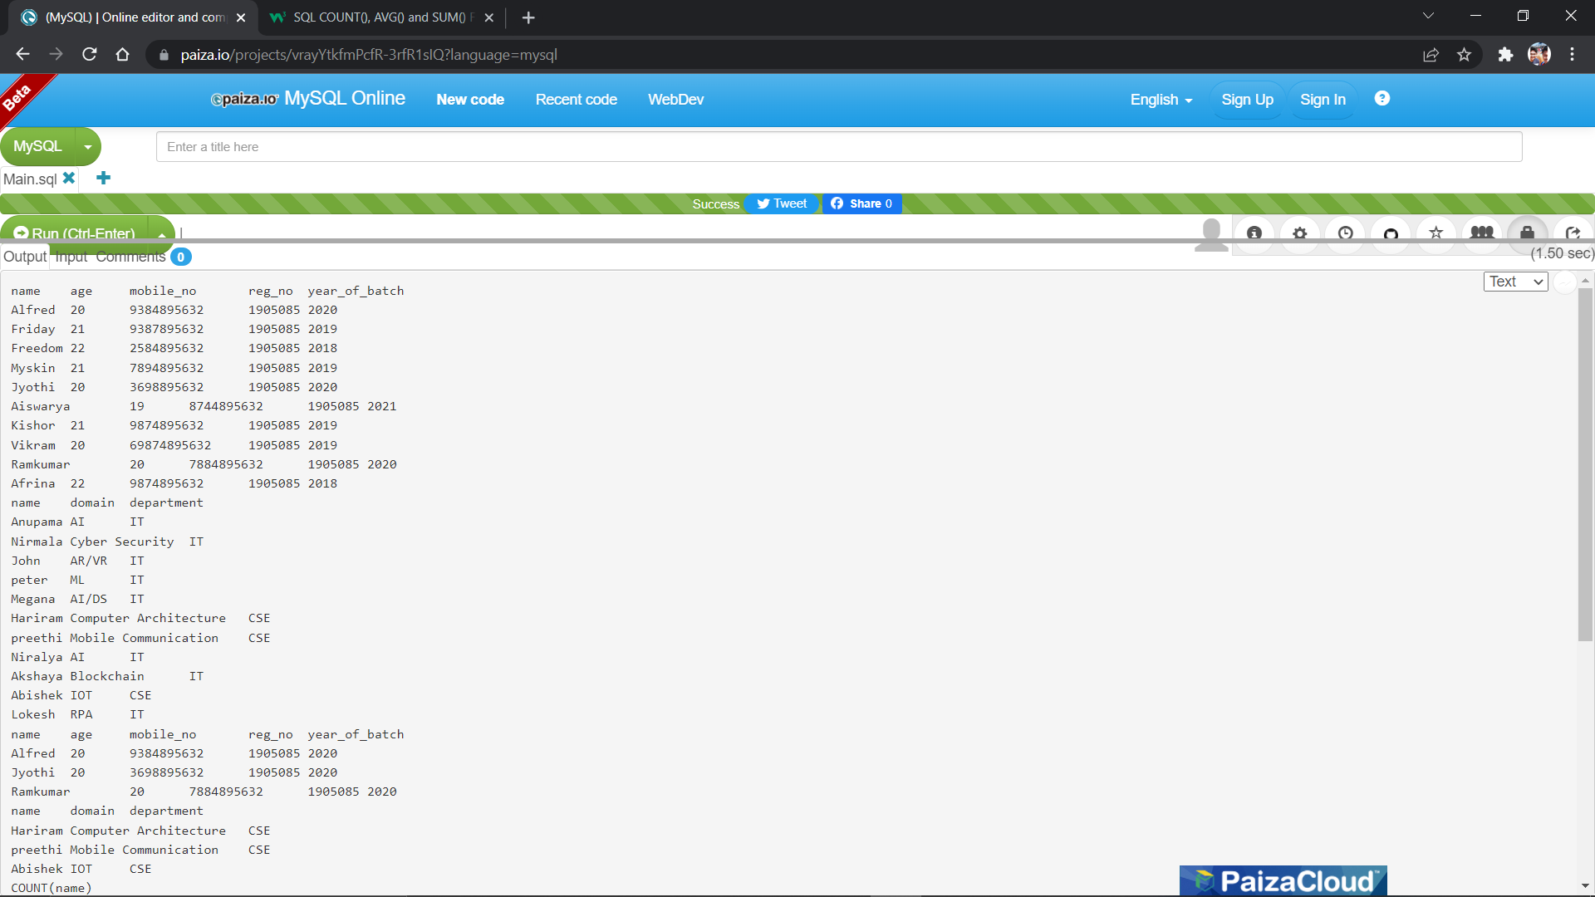

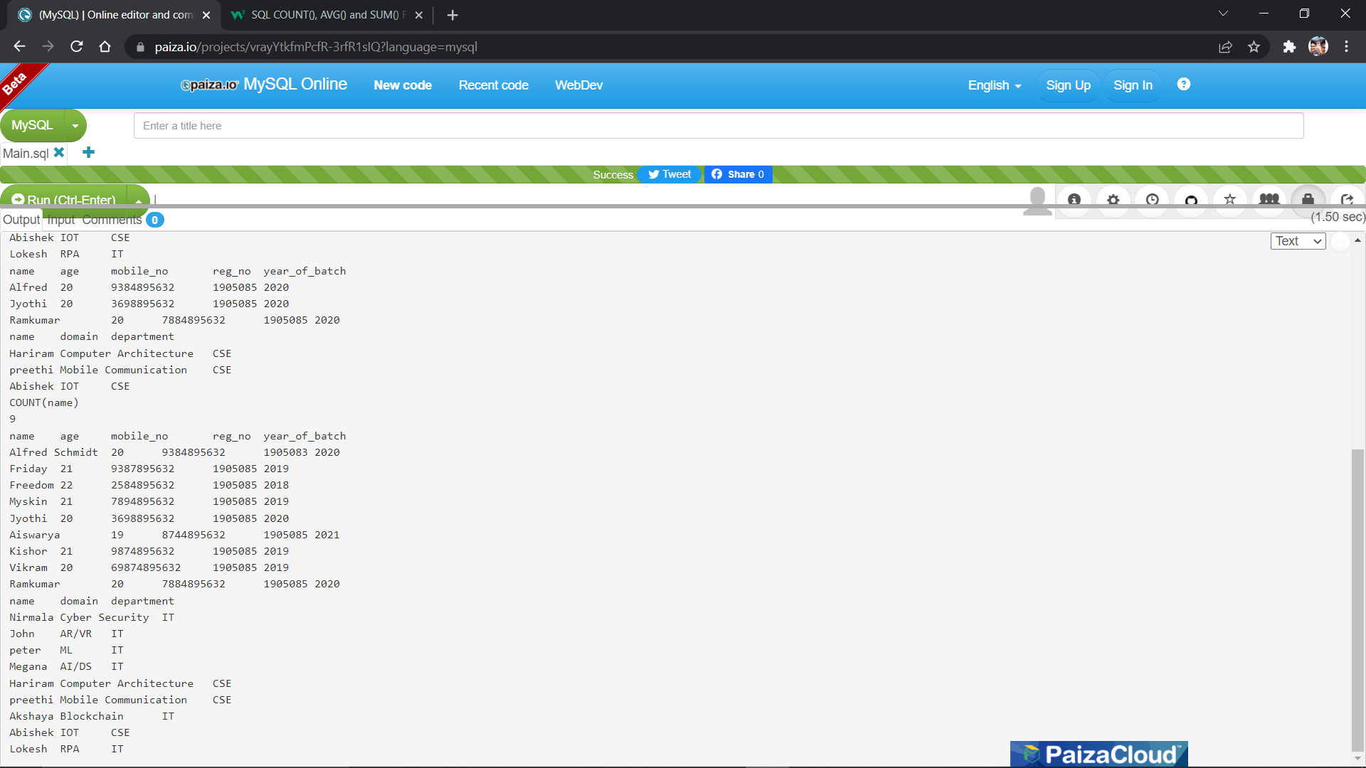

**2.JAVA BANK CALCULATOR:**

import java.util.*;  
public class Bank {  
int interest=10,repayDuration=20;  
  
void personalLoan() {  
interest=12;  
repayDuration=20;  
System.out.println("interest is= "+interest+"% ");  
System.out.println("Duration is= "+repayDuration);  
}  
void housingLoan() {  
interest=15;  
repayDuration=30;  
System.out.println("interest is= "+interest+"% ");  
System.out.println("Duration is= "+repayDuration);  
}  
void eduLoan() {  
interest=7;  
repayDuration=36;  
System.out.println("interest is= "+interest+"% ");  
System.out.println("Duration is= "+repayDuration);  
}  
void goldLoan(int grams) {  
interest =3;  
if(grams<100)  
repayDuration=24;  
else {  
repayDuration=48;  
interest=4;  
}  
System.out.println("interest is= "+interest+"% ");  
System.out.println("Duration is= "+repayDuration);  
  
}  
  
}

import java.util.*;  
  
public class ICICI extends Bank{  
ICICI(){  
super.interest=15;  
}  
void personalLoan(){  
interest=13;  
repayDuration=20;  
System.out.println("interest is= "+interest+"% ");  
System.out.println("Duration is= "+repayDuration);  
}  
void housingLoan(){  
interest=10;  
repayDuration=30;  
System.out.println("interest is= "+interest+"% ");  
System.out.println("Duration is= "+repayDuration);  
}  
public static void main(String[] args) {  
ICICI c1=new ICICI();  
c1.eduLoan();  
}  
  
}

import java.util.*;  
import java.lang.*;  
public class HDFC extends ICICI {  
void personalLoan() {  
interest=13;  
repayDuration=20;  
System.out.println("interest is= "+interest+"% ");  
System.out.println("Duration is= "+repayDuration);  
}  
void housingLoan() {  
interest=10;  
repayDuration=30;  
System.out.println("interest is= "+interest+"% ");  
System.out.println("Duration is= "+repayDuration);  
}  
public static void main(String[] args){  
Scanner sc=new Scanner(System.in);  
System.out.println("Select the Bank 1.ICICI 2.HDFC");  
System.out.println("Enter your choice 1 or 2");  
int n=sc.nextInt();  
ICICI h1;  
if(n==1) {  
h1=new ICICI();  
}  
else {  
h1=new HDFC();  
}  
System.out.println("Type of Loan 1.personal 2.housing 3.eduloan 4.golgLoan");  
System.out.println("Enter your choice 1 or 2 or 3 or 4");  
int loan=sc.nextInt();  
int gram=0;  
if(loan==4) {  
System.out.println("Enter no.of Grams");  
gram=sc.nextInt();  
}  
  
switch(loan) {  
case 1:  
h1.personalLoan();  
break;  
case 2:  
h1.housingLoan();  
break;  
case 3:  
h1.eduLoan();  
break;  
case 4:  
h1.goldLoan(gram);  
break;  
default:  
System.out.println("Invalid Choice");  
  
}  
}  
  
  
}

Output:

